Jenkins Day School
Welcome Back 2020-2021

Dear JDS Families:
We are excited to welcome you back to school on September 8th/9th for our 2020-2021 school year; God’s Happy Campers. This year is going to present unique challenges, but we approach this year with confident expectations due to your strong spirt of partnership and God’s continued blessings.
Our plan for the upcoming school year is outlined in this informational packet. We have spent countless hours researching the CDC guidelines for childcare, consulting with trusted medical professionals including the American Associates of Pediatrics, getting feedback from other area preschools and from the prayerful counsel of the Jenkins Church eldership. As you review the plan, please understand that keeping our community safe is our shared responsibility. It will take all of us working together to successfully navigate this latest challenge. This virus will be with us as we start the school year, but working together, we can minimize the risk and impact it has on our JDS community. Thank you in advance for doing your part to accomplish our shared goal.
We will continue to review our plans in the weeks to come and make you aware of any modifications. Please read through this information knowing that things may change as the circumstances of the COVID-19 virus change; and we appreciate your flexibility.
The staff at JDS is ready to welcome our students back and are committed to doing the important work of preparing them to be lifelong learners and
lifelong servants in God’s Kingdom. There is great comfort in knowing that the God we trust is much greater than our circumstances and His work continues in the face of our challenges. We cannot wait to see what He has in store!
With Love, Tracy and Staff

JDS Community

JDS Priorities:
To encourage emotional, social, physical, mental and spiritual growth in each child.
Create a safe and healthy school environment for all students, families and staff.
Provide creative and age appropriate games, manipulatives, toys, and lesson plans for each age level
Communicate daily about child’s activities, behavior, concerns, health,
safety and goals
Provide children with the foundations needed to grow as Jesus did – “in wisdom and stature, and in favour with God and man” (Luke 2:52)
Pray actively for your child and family
•

•

•

•

•
•
- Commit to protecting the overall health and well being of our community
- Support one another this school year that will require flexibility, transparency, and patience to be successful.
- Keep children home when they feel unwell or display COVID-19 symptoms.
- Communicate openly and honestly regarding the health of all family members and the possibility of exposure to the virus.
- Rejoice in the positive and wonderful ways that God continues to bless our JDS family.
JDS IS FAMILY
As with any family, we commit to caring for one another.
Family, Student, and Staff
Expectations:

Children and Staff will have their temperatures taken before entering the church. No one will be allowed to attend or work if temp is above 99 degrees (for adults and children over 2 years); or 100 degrees for children under 2 years. Visual inspections will be done to check for signs of illness, which could include flushed cheeks, rapid breathing or difficulty breathing (without recent physical activity), fatigue, or extreme fussiness. Temperatures may be checked during the day if symptoms should arise.
COVID-19 Protocols In a Nutshell
- Parents and staff will be required to fill out a COVID-19 Screening Questionnaire before being admitted to the program. We will reserve the right to require additional questionnaires as the school year progresses.
- In case of illness, students and staff will not be allowed back before 48 hours and may require a doctor's note. If your child gets ill during the day, the child will be isolated away from the other children, you will be contacted and must pick up ASAP.
- Parents will NOT be allowed in the building. Staff members will escort children to classrooms. There will be 2-3 check in stations, and we ask that you socially distance while waiting for your child's entry into the building. Check-in procedures will be done by a staff member to prevent spreading of germs. (Please let me know if you have concerns about not escorting your kids to class!)
- No entry of students after 9:30 each day.
- Hand washing and sanitizing for staff and students upon arrival and continuously throughout the day.
- Doubled frequency of cleaning and sanitizing toys, high traffic areas such as bathrooms, doorknobs, light switches, countertops, nap pads, toilet training potties, tables, chairs, cubbies, and playground structures multiple times throughout the day.
- Our schedule has been modified to limit the number of children and staff in one area. Class sizes are limited to 8-9 students.
- When feasible, staff will wear masks when outside of their classroom area. PPE WILL be worn with interacting with parents. We will continue to comfort, hug and hold your babies as they often need that hands-on contact. Children are NOT required to wear masks.

COVID-19 Protocols

Normal Operation | 0 Positive Covid-19 active cases in our community | Normal operations and procedures followed
Low Spread | Less than 0.5% of positive Covid-19 active cases in our community | Preschool will be in-person with Covid-19 procedures followed
Medium Spread | Between 0.5%-1% of positive Covid-19 active cases in our community or as determined by the Health Department | Preschool will be in-person with Covid-19 procedures followed
High Spread | Greater than 1% of Covid- 19 active cases in our community | Preschool will be CLOSED; arrangements may be made for essential/working families
DISCLAIMER: Jenkins Day School will reserve the right to close preschool at any given time if we are experiencing a high level of active Covid-19 cases within our preschool, inability to staff classrooms safely due to staff illness, staff children’s school(s) closed, while WCS remains open or the church elders requires church building closure. If preschool is closed, the families will receive a text and/or email by 8 am the morning of closure.

IN THE EVENT OF COVID-19 EXPOSURE
In the event there is a confirmed case of Covid-19 in your child’s classroom, you will be notified immediately. We will contact the Williamson County Health Department and they will guide us through closure procedures. Each case will be evaluated individually based on recommendations from the Health Department. Areas that were used by the infected person will be closed for the amount of time recommended by the Health Department and sanitized according to their standards. This could mean that individual classes could be cancelled for up to 14 days.

In the event a child or staff member is exposed to a confirmed case of Covid-19 OUTSIDE of the facility, that individual will be asked to quarantine for 14 days.

The health and safety of our children and staff will depend on YOU. We kindly ask that you are transparent in reporting exposure. We also ask that you ERR ON THE SIDE OF CAUTION when determining when to send you child to school.

COVID-19 Protocols

Symptom | Monitor Child | Pick-Up Required
FEVER | 99.0° – 99.9° | 100° or above
COUGH | - Infrequent  - Non Disruptive  - No fever  - No shortness of breath | If accompanied by a frequent and disruptive cough
SORE THROAT | If only symptom | When accompanied by 1 other COVID-19 symptom
HEADACHE | If only symptom | When accompanied by 1 other COVID-19 symptom
LOSS OF TASTE/SMELL | If only symptom | When accompanied by 1 other COVID-19 symptom
CHILLS | If only symptom | When accompanied by 1 other COVID-19 symptom
MUSCLE ACHES | If only symptom | When accompanied by 1 other COVID-19 symptom

Illness Protocols

SYMPTOM/ILLNES | Should NOT attend | May Return When
FEVER | - Temperature at 100° or above  - Student unable to participate in school activities as determined by staff | Temperature is below 100° without the use of a medicine that reduces fever (Advil or Tylenol) for 48 hours
PINK EYE/ CONJUNCTIVITIS | - Eye redness, itching, irritation, swelling in one or both eyes  - Thick and purulent discharge  - Matted eyelashes | - Bacterial Conjunctivitis – after 24 hours of starting antibiotics drops  - Viral Conjunctivitis – note from doctor stating no longer contagious.
COUGH/RUNNY NOSE | - Frequent, uncontrollable, disruptive  - Green mucus discharge or discharge that requires constant nose wiping  - Temperature at 100° or above | - Infrequent, non disruptive  - Clear and infrequent nasal discharge  - No fever for 48 hours
DIARRHEA OR VOMITING | - Diarrhea or Vomiting occurs without 24 hours of school start time | - Free from diarrhea or vomiting for more than 24 hours  - Able to tolerate regular  food  - No fever for 48 hours
HEAD LICE | Live lice are present and/or nits are present | - Proof treatment is provided; release from doctor or lice treatment center  - Director examines head  confirming lice free
RASH OR SKIN INFECTION | - Rash or signs of skin infection that have not been seen by a doctor  - Temperature at 100° or above | - Rash free or written release from doctor  - After 24 hours on antibiotic/antifungals for skin infection  - No fever for 48 hours.

Illness Protocols

SYMPTOM/ILLNES | Should NOT attend | May Return When
SORE THROAT | - Sore throat with swollen lymph nodes, headache, nausea and/or fever  - Positive culture for Strep Throat | - Resolution of accompanying symptoms at least 24 hours  - 24 hours antibiotics if positive for Strep  - No fever for 48 hours
CHICKEN POX | - Itchy pink/red rash with small fluid-filled blisters  - Temperature at 100° or  above | - All lesions are crusted over and dry with no new lesions, usually 5-7 days  - No fever for 48 hours
POSITIVE TEST OR SYMPTOMS OF COVID 19 | Positive Test or Two or More Symptoms  - Fever  - Cough  - Shortness of breath or difficulty breathing  - Fatigue  - Muscle or body aches  - New loss of taste or smell  - Sore throat, congestion, runny nose  - Nausea or vomiting, diarrhea | - 10 days have passed since symptoms first appeared plus symptom free for 72 hours OR  - Note of release from healthcare provider with alternative diagnosis
KNOWN EXPOSURE OR CLOSE CONTACT WHO TESTED POSTIVIE OR HAS PROBABLE CASE OF COVID 19 | - Exposure to close contact (within 6 feet for at least 10 minutes) or living in same household (from 2 days before symptom onset or positive test, if asymptomatic)  - Consult healthcare provider or local health department for specific guidance | - Home Isolation complete for 10 days after last exposure to close contact  - No symptoms of Covid 19 have developed during the home isolation period

Due to our COVID-19 procedures, we are limiting people inside the building and ask that you allow our staff to escort your children to their class. Of course, we want you to feel comfortable leaving your child with us; so if you would like to escort them, please wear a mask and make your trip inside quick. We will be taking temperatures of everyone who enters the building and ask that you use hand sanitizer and/or baby wipes on your/your child’s hands.
HOLIDAYS:
We follow the Williamson County Schools academic calendar.

Arrival and Dismissal
In order to comply with social distancing, we will stagger arrivals and dismissals. If your last name begins with the letters A-L, please arrive at 8:50 each day. If your last name begins with the letters M-Z, please arrive at 9:00. If your child is in the Baby, Young Toddler, PreK and Older classes, you will enter at the door at the very end of the
SAFETY AND SECURITY:
Children will only be released to a parent, guardian, or approved adult. Please sign in your child in and out each day and provide a number where you can be reached during the preschool hours. Parents should notify director and/or teacher if there is a change in who will be picking up their child. Identification may be required. All church doors will be locked from 9:30 until 1:45 while children are present. Playground will be used only when supervised by teachers. Plans are in place for tornado warnings, fire and intruder. Our teachers are required to have a background check and have received training in Safe Sanctuary.
INCLEMENT WEATHER:
If Williamson County schools are closed due to inclement weather, JDS will be closed as well. Late arrivals and Early Dismissals will also operate on the WCS schedule.
gym. If your child is in the 2’s classes or Preschool classes, you will enter at the usual day school entrance. If you have more than one child in different areas, please use the usual day school entrance.
Please be aware of social distancing when checking your children in; and consider waiting inside your car until the line has cleared.

Dismissals will follow the same schedule as arrivals. A-L will dismiss at 1:50 and M- Z at 2:00. Pick up will be from the same door as arrival. Again, be aware of social distancing procedures

FEES:
DISCIPLINE:
We expect your children to behave in an obedient and respectful manner. Appropriate behavior will be praised. Despite all our attempts to encourage positive behaviors, children will still misbehave at times. When this occurs, we treat the situation as an opportunity for teaching rather than punishment.
When necessary, our method of discipline is warning the child and “time-out” or
the “thinking spot.” If your child becomes extremely unruly during the day; the director reserves the right to call the parent to pick up early.
JDS is a community outreach effort and not a for- profit organization. Therefore, we try to keep our fees reasonable. Tuition for one child is $26.00 per day. In order to make our program more affordable for families with more than one pre-school child, we offer a reduced rate for each child after the first. The tuition rate for additional children is $24.00 per day. Our tuition collection will look a little different this year due to COVID-19, and the potential of school closures.
Tuition payments will be due on the first day of the month. We are moving to this “pay on the month” schedule to try to avoid refund/reimbursement challenges. IF we have closures due to COVID-19 we will do what we can to credit your account, BUT WE CANNOT GUARANTEE FULL REIMBURSEMENT.
Remember, you are responsible for the full month’s tuition even if your child misses due to illness, vacation, etc. A non-refundable registration fee of
$75.00 and a supply fee of $50.00 for the fall program will be required upon enrollment. Please note that you will not be charged for days when Williamson County Schools are closed for holidays and/or administrative days. However, we will not be able to reimburse for inclement weather days. Similarly, we cannot reimburse for days your child is not present. Should you need financial assistance, please see the director. If your plans should change, kindly give a month’s notice to the director. This will give us ample time to inform those on a waiting list of an opening. The balance of that month tuition will not be refunded.

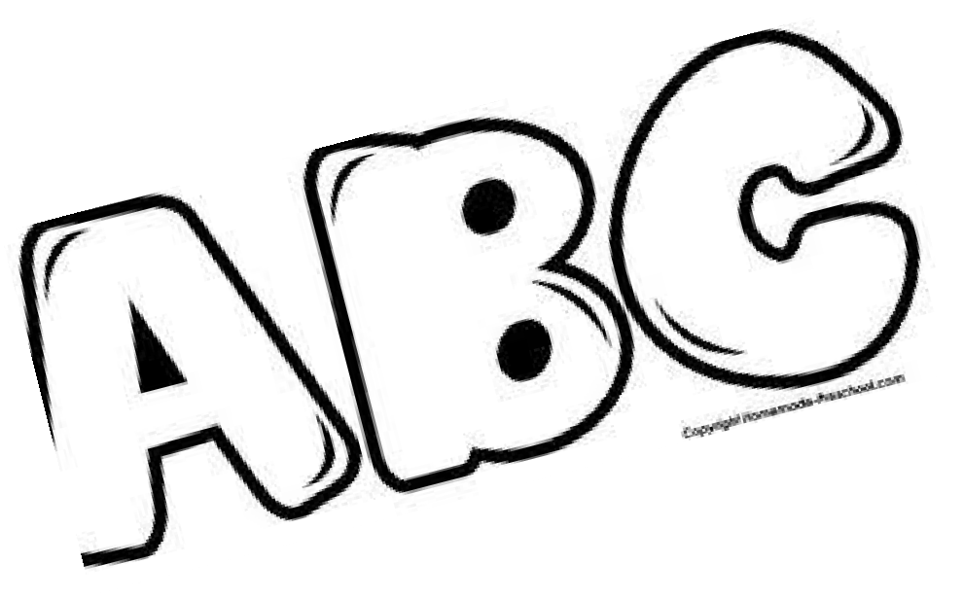CURRICULUM:
Jenkins Day School is blessed to have a teaching staff with many talents. This year in PreK, we will use the Frog Street Press Alphabet and Color series. We will use the Handwriting Without Tears method for handwriting.
Additionally, we will use a variety of hands on Math Their Way activities to practice counting and number sense.
The Preschool students will use a curriculum designed just for JDS using Frog Street Press and Easy Breezy curriculums.

In addition to academic learning, we offer many opportunities for “socialization.” Our thoughts are that children learn through play and interaction with their peers. The activities in the classroom are aimed at teaching the importance of sharing, listening, and working in groups and taking turns.

We understand the importance of “gross motor” functions such as running, jumping, and skipping, and have provided areas where the children can increase their muscle strength. Our children will have ample time playing in the gym and outside as weather permits.

JDS is especially blessed to have a talented music director on staff. The children will have the opportunity to participate in music class where they will learn through musical play. The children will also participate in weekly structured Physical Education classes and chapel.

Our plan is to have monthly “in house” field trips where our students can be exposed to various outside resources such as musicians, community helpers, occupations, artists, animals, etc. Should you have a special talent to share with the kids, please communicate that with the director.

Helpful Hints:
- Children in the toddler classrooms must bring a mat for rest period. All children must rest quietly, not necessarily nap, during rest time. Please bring any item (pacifier, blanket, “lovey”) that would be necessary for your child to rest comfortably. All bedding will be placed in large Ziplock bags to prevent cross contamination. PLEASE LABEL EVERYTHING with your child’s name!
- Dress your child comfortably for active, and possibly messy, play! We ask that you dress younger children in clothing that will ease diaper changes. Use disposable diapers and bring extras! To promote independence, older children should be dressed in clothing that can be easily managed in the rest room. For your child’s safety, we will ask them to wear shoes at all times. ALL CHILDREN SHOULD HAVE AN EXTRA SET OF CLOTHES IN THEIR BAG AT ALL TIMES.
- Each child must bring a lunch each day. We ask that you be mindful of our teachers and provide lunches that your child can easily manage. A light morning snack will be provided.

Please make the director and teacher aware of any allergies your child may have. The director reserves the right to prohibit any peanut products from the preschool. This decision will be made based on severity of the child’s allergy and their particular classroom.
- We discourage bringing toys from home. This may create a distraction in the classroom when favorite toys do not want to be shared with the other students. If an item is brought, it must remain in their “cubby” and not to be removed from the classroom and taken to the gym, music room, or outside. It is the responsibility of the parent and child to keep up with special things brought from home.
- We will be happy to celebrate your child’s birthday and encourage the parent to provide “bite size” cupcakes, cookies, muffins, etc. Please let your child’s teacher know when you will be celebrating the child’s big day! Special occasions and holidays are celebrated in the classrooms throughout the year.
- Children who are 3 years of age are required to be in the process of potty training and must be able to ask to use the restroom. Diapers are not allowed, but pull-ups are acceptable, if they are used for toilet training purposes only. We highly encourage the child to be fully independent in these skills by 3 years 6 months.

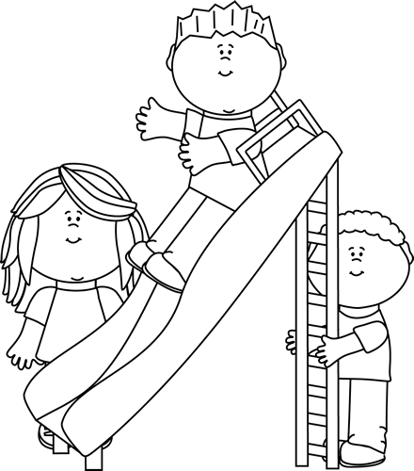
Specials
Music, P.E. and Bible class will take play once a week in small groups. All supplies used will be sanitized before each group.
Snack/Lunch
- In order to decrease cross contamination, please bring your own snack each day
- Babies/Young Toddlers will eat snack in their classroom and lunch in designated highchairs in the gym
- 2’s will eat snack and
lunch in their classroom
- Preschool/PreK will eat snack in their classroom and lunch in the gym and will sit with their class.
Classroom Classroom sizes will be limited to no more than 8-9 students to comply with social distancing guidelines
School Day

Recess
The children will be able to play outside with their friends each day, weather permitting. Each age group will have their own designated time on the playground. Play equipment will be sanitized before each group.

